## **SQL**

<https://www.udemy.com/topic/sql/free/>

* Install SQL Server.
* Create database & 3 tables
  + Employees
  + Departments
  + Salary_grade

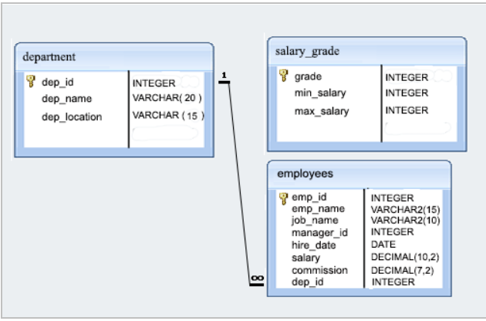

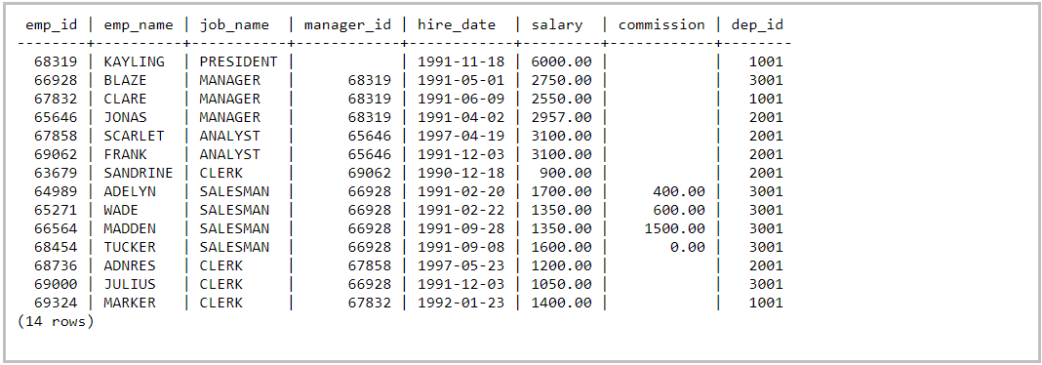

**1.** From the above table return complete information about the employees.

**Sample Output:**

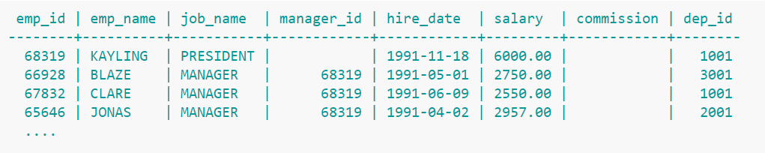

**2.** From the table, write a SQL query to find the salaries of all employees. Return salary.

**Sample Output:**

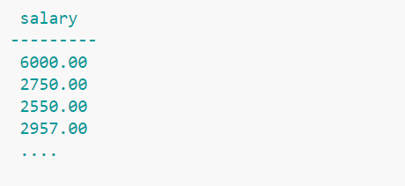

**3.** From the table, write a SQL query to find the unique designations of the employees. Return job name.

**Sample Output:**

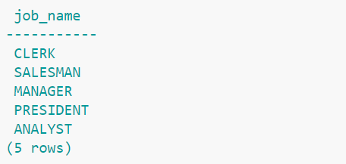

**4.** From the following table, write a SQL query to list the employees’ names, increase their salary by 15%, and express the number of Dollars.

**Sample Output:**

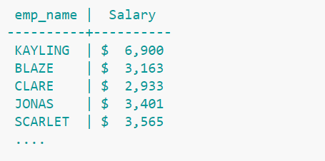

**5.** From the following table, write a SQL query to list the employee's name and job name as a format of "Employee & Job".

**Sample Output:**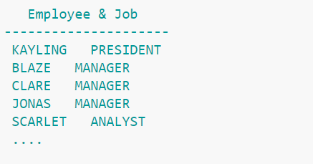

**6.** From the following table, write a SQL query to find those employees with a hire date in the format like February 22, 1991. Return employee ID, employee name, salary, hire date.

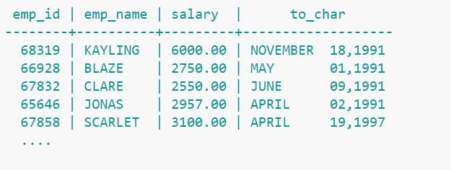

**7.** From the following table, write a SQL query to count the number of characters except the spaces for each employee name. Return employee name length.



**8.** From the following table, write a SQL query to find the employee ID, salary, and commission of all the employees.

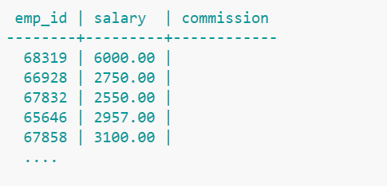

**9.** From the following table, write a SQL query to find those employees who do not belong to the department 2001. Return complete information about the employees. (Using **NOT IN**)

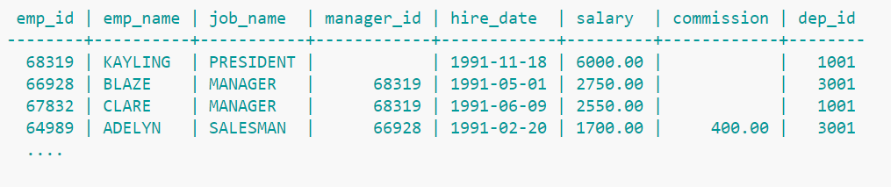

**10.** From the following table, write a SQL query to find those employees who joined before 1991. Return complete information about the employees.

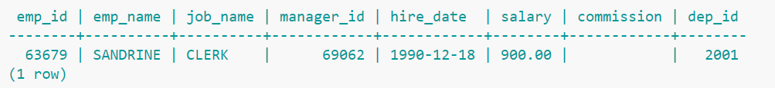

**11.** From the following table, write a SQL query to compute the average salary of those employees who work as ‘ANALYST’. Return average salary.

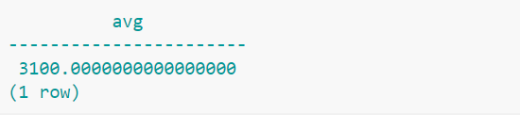

**12.** From the following table, write a SQL query to find the details of the employee ‘BLAZE’.

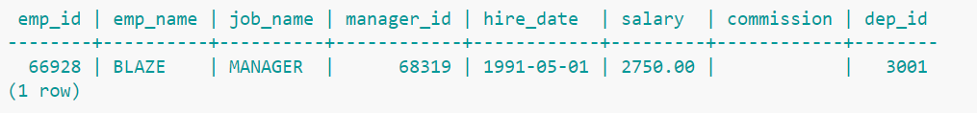

**13.** From the following table, write a SQL query to find those employees whose salary exceeds 3000 after giving a 25% increment. Return complete information about the employees.

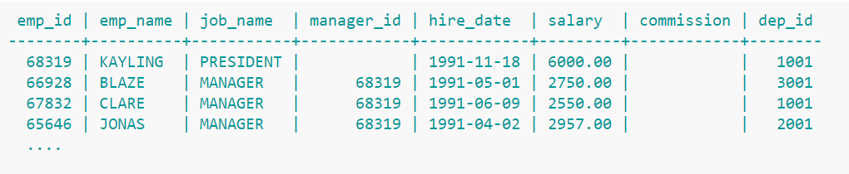

**14.** From the following table, write a SQL query to find those employees who joined in the month January. Return complete information about the employees.

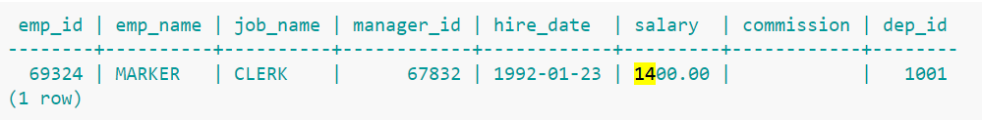

**15.** From the following table, write a SQL query to find those employees who joined before 1st April 1991. Return employee ID, employee name, hire date and salary.

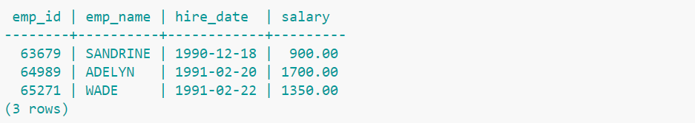

**16.** From the following table, write a SQL query to find the name and salary of the employee FRANK. Salary should be equal to the maximum salary within his or her salary group.(Using **Between**)

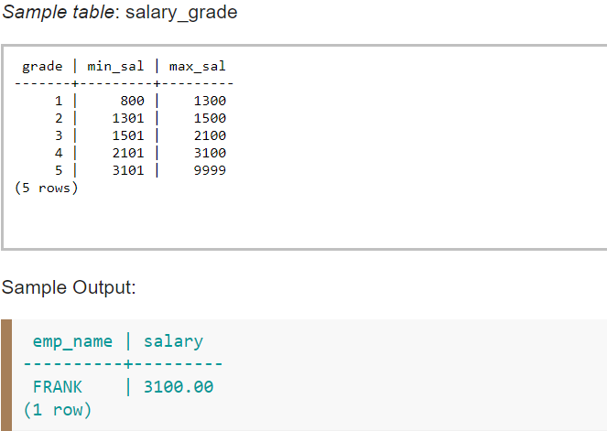

**17.** From the following table, write a SQL query to list all the employees except PRESIDENT and MANAGER in ascending order of salaries. Return complete information about the employees. (Using **Order By**)

**Sample Output:**

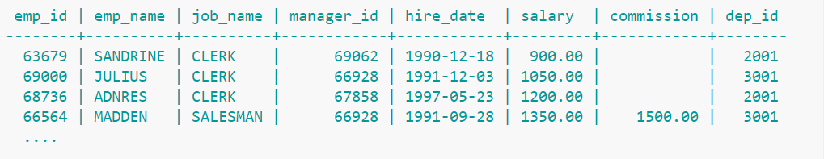

**18.** From the following table, write a SQL query to find the highest salary. Return the highest salary.

**Sample Output:**

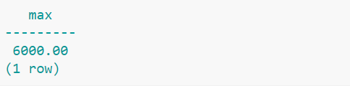

**19.** From the table, write a SQL query to find the average salary and average total remuneration (salary and commission) for each type of job. Return name, average salary and average total remuneration. (Using **GROUP BY**)

**Sample Output:**

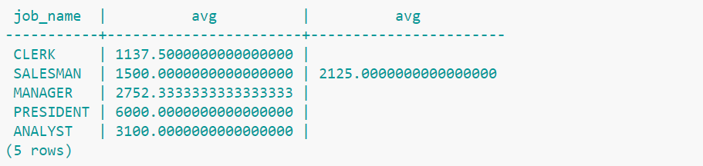

**20.** From the following table, write a SQL query to find those employees who work in the department ID 1001 or 2001. Return employee ID, employee name, department ID, department location, and department name.(Using **IN** clause)

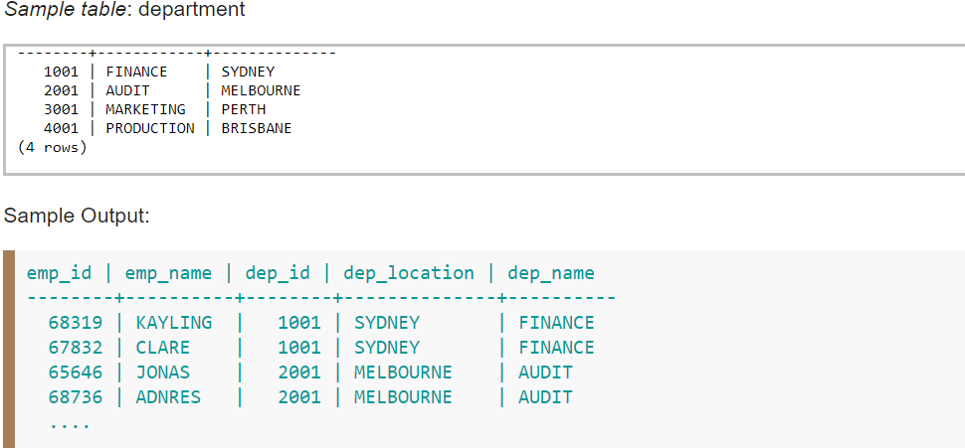

**21.** From the table, write a SQL query to list the managers and number of employees work under them. Sort the result set in ascending order on manager. Return manager ID and number of employees under them.(Using **GROUP BY & ORDER BY**)

**Sample Output:**

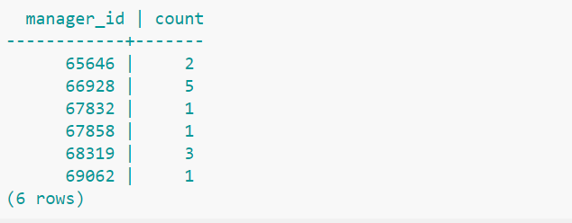

**22**. From the table, write a SQL query to find those departments where at least two employees work. Return department id, number of employees.(**GROUP BY** & **HAVING**)

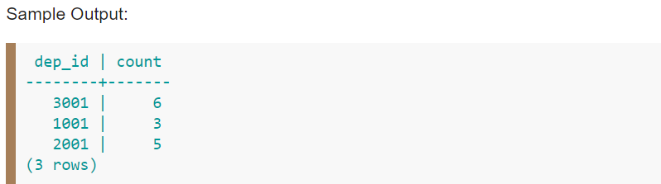

**23.** From the table, write a SQL query to find those employees whose names contain the character set 'AR' together. Return complete information about the employees. (using **‘like’**)

**Sample Output:**

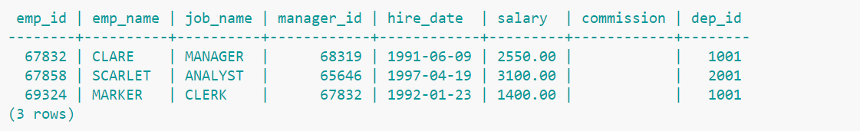

24. Add a column for “Gender” in the employee table and update each row accordingly.



25. From the above table we need to retrieve all employees except ‘Manager’ & ’President’ Job name.

26. From the above table we need to display ‘Management Level’ - labelname for ‘President’,’Manager’,’Analyst’ jobs and ‘Employee Level’ - label name for ‘Salesman’,’Clerk’ job names.

27. Update commission field to 650.00 for job name titled as “analyst” in “employee” table using “Exist” clauses.

28. Please go through…

* Stored Procedure
* Trigger
* Function in SQL
* TEMP using IN
* INDEX